

First Paying Clients- Week Two Playsheet

1. Build Your Own- Packaging/Pricing
Select from the options below, to create packaging & pricing that works for your business, right now.

First choose (circle one): Bundles Single Option Beta Program

If bundles, you can review the examples below, for your easy reference and then fill in the structure with a draft of your packaging/pricing below, after example #3.
(Remember to take imperfect action!)

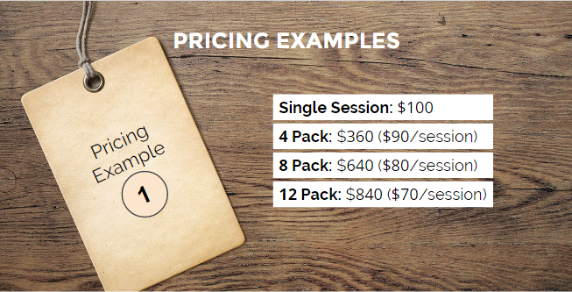
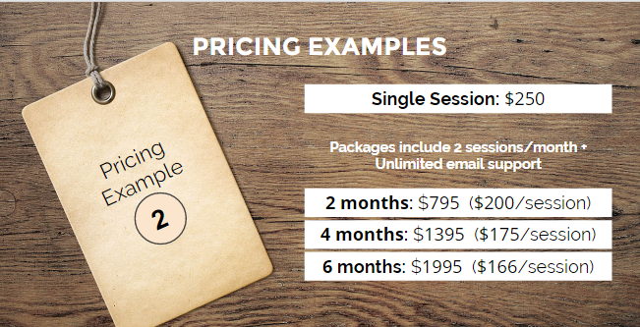
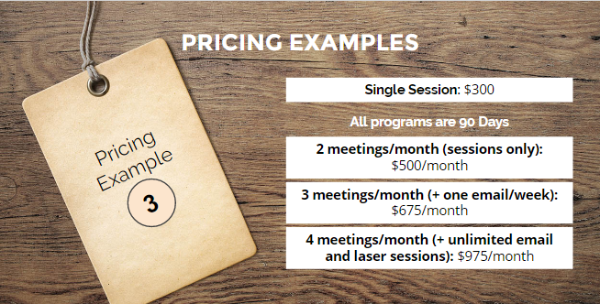

Single Session:

X Bundle =

X Bundle =

X Bundle =

Then, name it a result oriented title! >> _______________________________

–
If you chose Beta Program...

What are the details of the beta program? Is it an individual or group program? If it is based on completing a project, what is a scope of the project? List any of the details you feel clear about, or are visioning and would like to try:

Estimated full value of the program**: $

Special beta pricing: $

**Not sure about the value? You can do market research to see what the range of pricing for a similar service currently is in the marketplace. You can also use the interview strategy (presented in week one) to learn about how valuable your solution is to your potential clients. Simply ask, “What would a solution for this be worth to you?”

If you are feeling nervous about the beta program or bundles, remember:

You can only truly know what works by trying it out!

Here are some other mindset tips and tools you can pull from, if you are feeling nervous about anything packaging and pricing related:

Circle your favorite three, and write in any other tips or affirmations you'd love to reference in the future.

- Remember that you truly care about your clients, and that is invaluable
- Collect feedback throughout your programs. Your clients will feel honored that you care what you think, and you'll be able to improve what you're offering as you go (rather than by trying to predict everything in your head).
- The fastest path to becoming an excellent service provider in business is to start delivering your service now, start accepting money now, and to work with as many paying clients as you can
- Everybody is learning and has both experiences to draw from, and horizons they haven't covered yet. The learning never stops, so embrace the process and acknowledge that you have enough to start helping people, right now!
- You are nervous because you a choosing to live a life that matters, rather than a life of mediocrity. You are awesome!
- If you continue to take consistent action and listen to the needs of your clients, your success is inevitable.

Sharing your packaging and pricing out loud will help make it real! List 3 people who you could share your packaging and pricing with voice-to-voice, to build your confidence and get supportive feedback that your program is easy to understand.

1.
2.
3.

